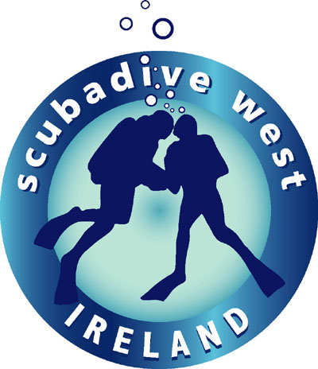

PRESS RELEASE

‘Paddy’ earns top PADI rating.

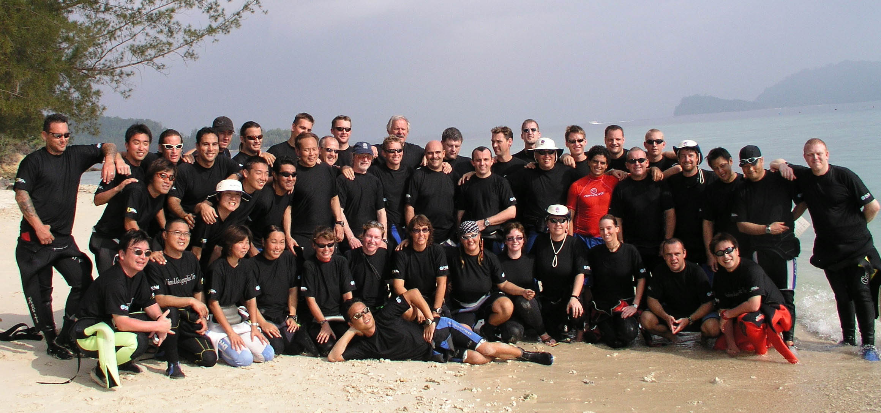
The staff and clients at Scubadive West are delighted at the news that one of its Directors, Cillian Gray, has just successfully completed the prestigious PADI Course Director Trainer Course (CDTC). 46 candidates from all over the world participated in a bid to earn PADI’s highest professional SCUBA Instructor rating. Successful candidates are awarded the coveted status of ‘Course Director’ which enables them teach PADI Instructor level courses.
The CDTC was run at the Magellan Sutera Hotel in Kota Kinabalu, Sabah, Malaysia from 8th through 19th March 2005. Cillian Gray, from Scubadive West in Galway was the only representative from Ireland to attend the programme . He did an excellent job, earning his Course Director status with flying colours, although he has been an active scuba diver since the tender age of 13 and has been working as a full-time PADI instructor for 16 years!

The Professional Association of Diving Instructors (PADI) is a global corporation with service offices worldwide. Affiliated with several companies, foundations and organizations that provide services to the diving industry, PADI’s Travel Network provides travel services, The Diving Science and Technology (DSAT) Corp. develops educational and promotional programmes and products and the PADI Diving Society is an organization for enthusiasts encouraging active participation in diving. The Project AWARE Foundation is a nonprofit organisation established by PADI to support environmental and educational efforts through grant programmes and other efforts.
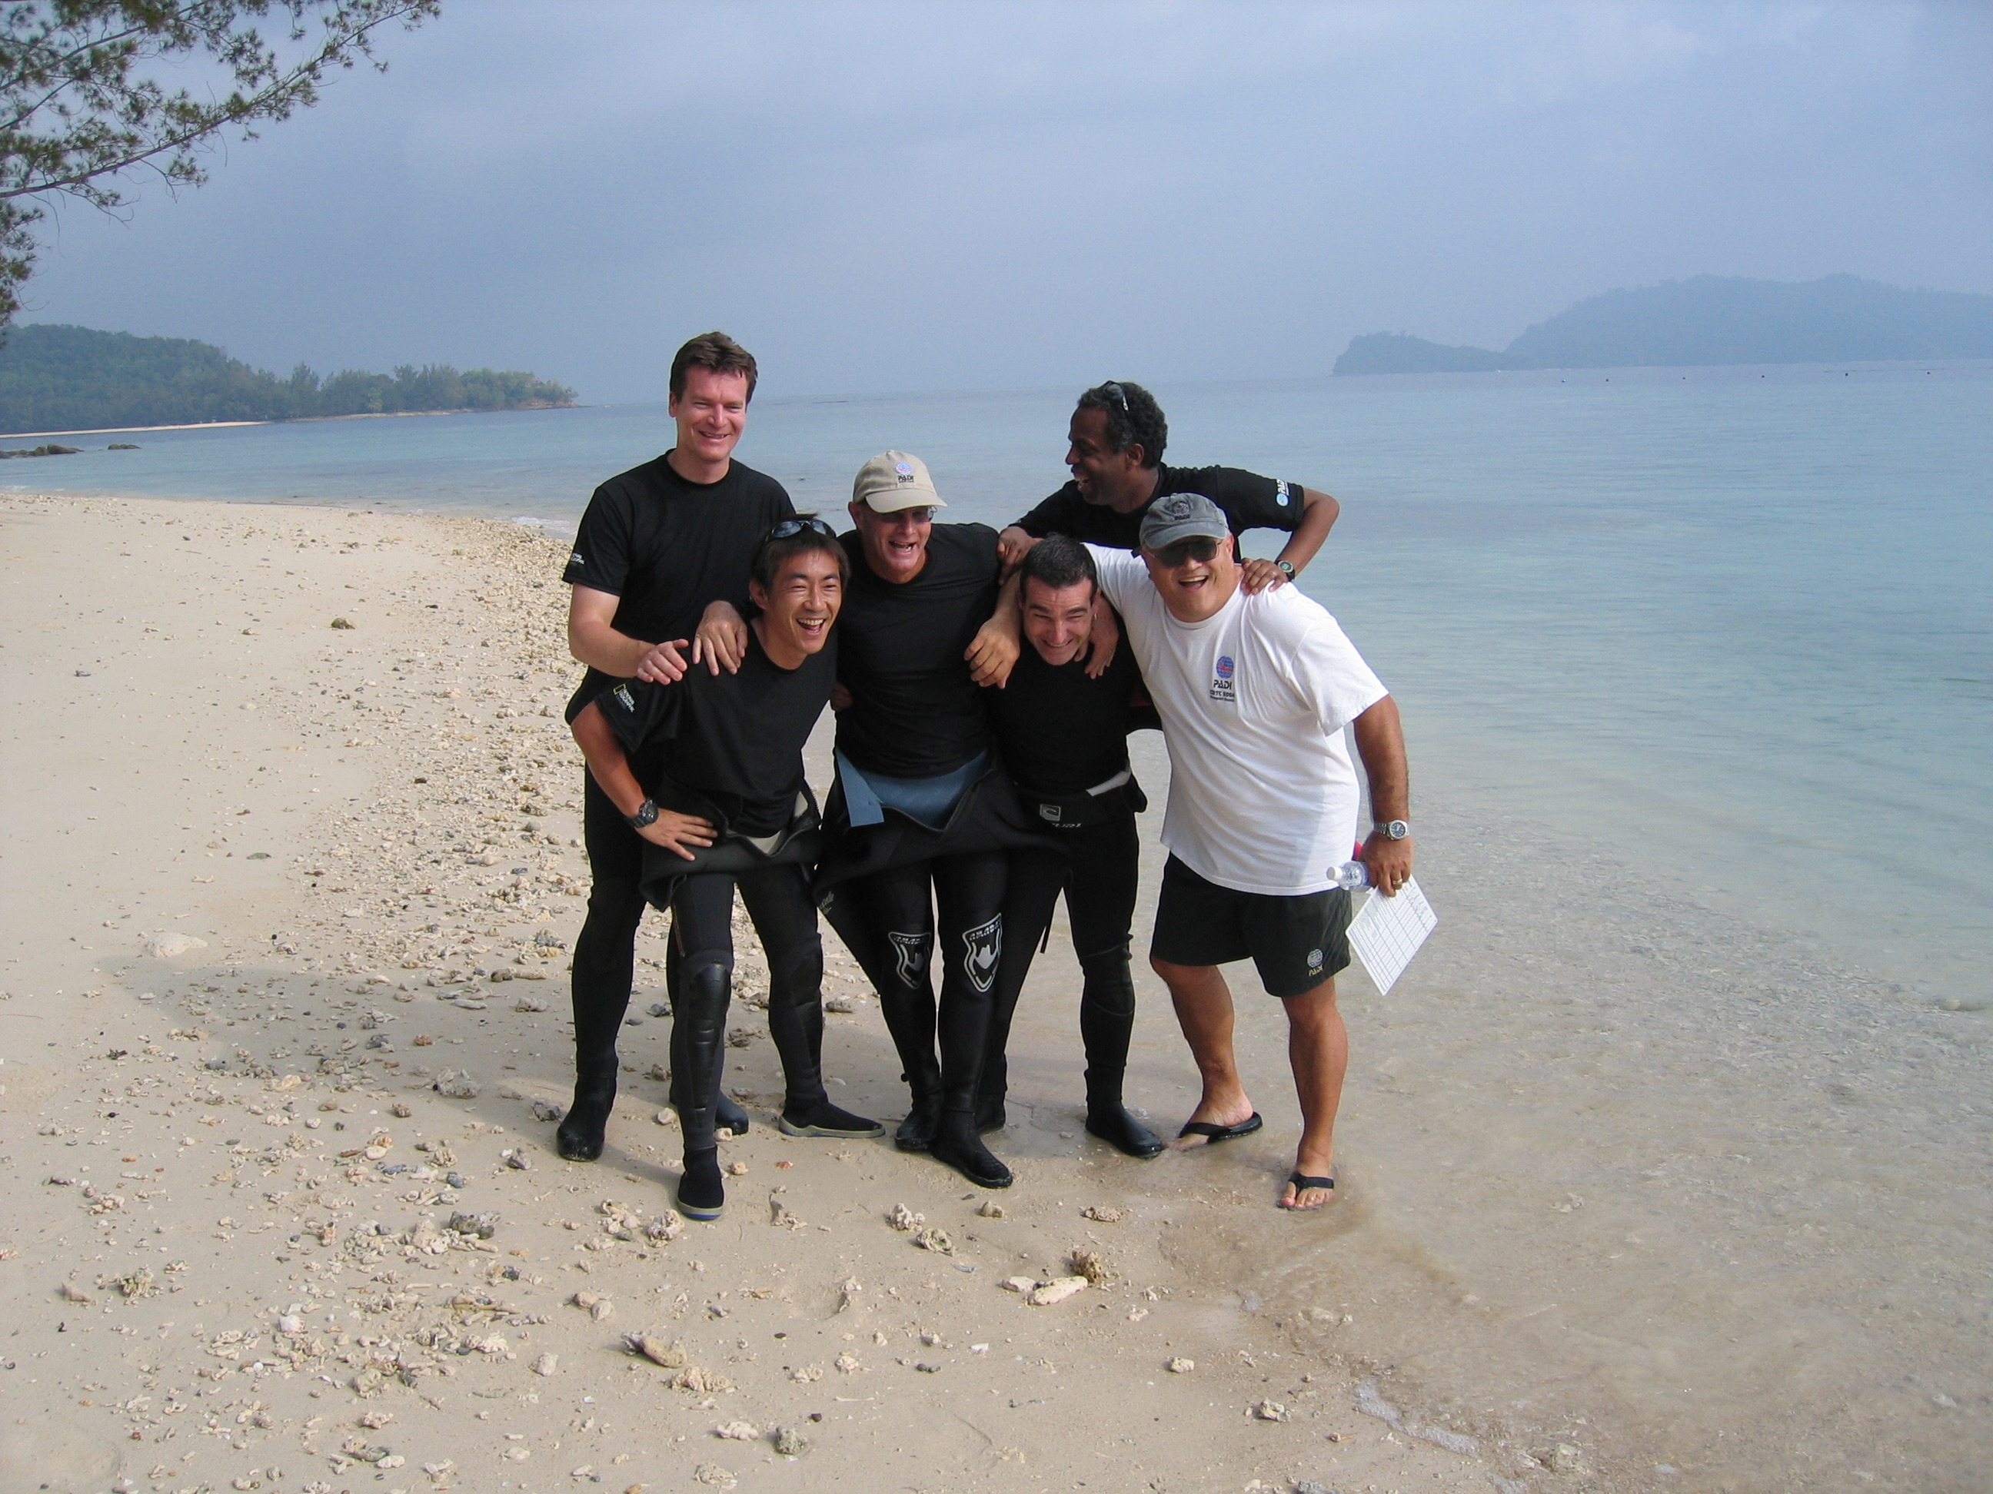
Staff from PADI Americas, PADI International Ltd, PADI Asia Pacific, PADI Japan and PADI Europe travelled to Kota Kinabalu for the month of March to present the programme with great enthusiasm!

The ‘Open Water SCUBA Instructor’ rating is the first PADI Instructor level attained by its dive professionals. During their training, instructor candidates review PADI Standards, procedures, philosophies and teaching methods as well as honing their practical teaching ability, watermanship and diving knowledge. After successfully completing an Instructor Examination, Instructors take responsibility for introducing people to scuba diving through various PADI programmes and courses. Teaching status PADI Instructors may conduct the entire range of PADI programmes from Discover Scuba Diving up to Divemaster.

Employment opportunities exist for PADI Instructors in locations throughout the 160 countries where affiliated centres exist, typically the most exotic and scenic areas of the world. The typical lifestyle of an Instructor involves meeting people, going places and offering people experiences that will stay with them as memories for the rest of their lives. The Irish diving industry offers employment opportunities in numerous PADI centres, Dive Shops and Resorts due to the world class yet little known, diving off the coast of Ireland.

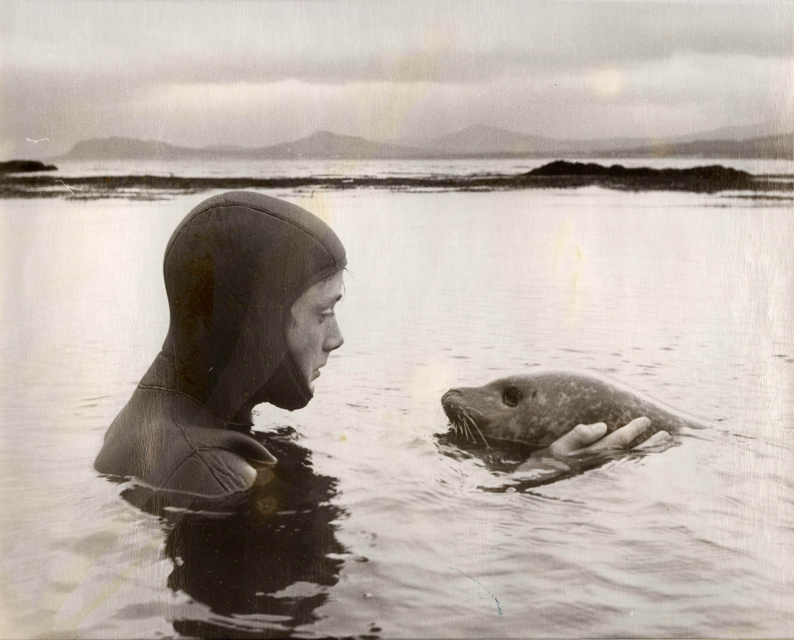
Cillian comes from a family of divers. His father Shane (PADI instructor) and mother Ollie, set up one of the first dive clubs in Ireland back in the early 70’s and, in 1991 went on to set up Scubadive West one of the first PADI dive centres in Ireland. Situated on the beautiful west coast of Ireland, Scubadive West is now run by Cillian and his brother Breffni, also a PADI instructor as are his other brothers Tiernan and Ronan. Ronan is a qualified Course Director working in the diving industry in San Diego while Tiernan braves the cold North Sea as a commercial diver on the oil rigs.

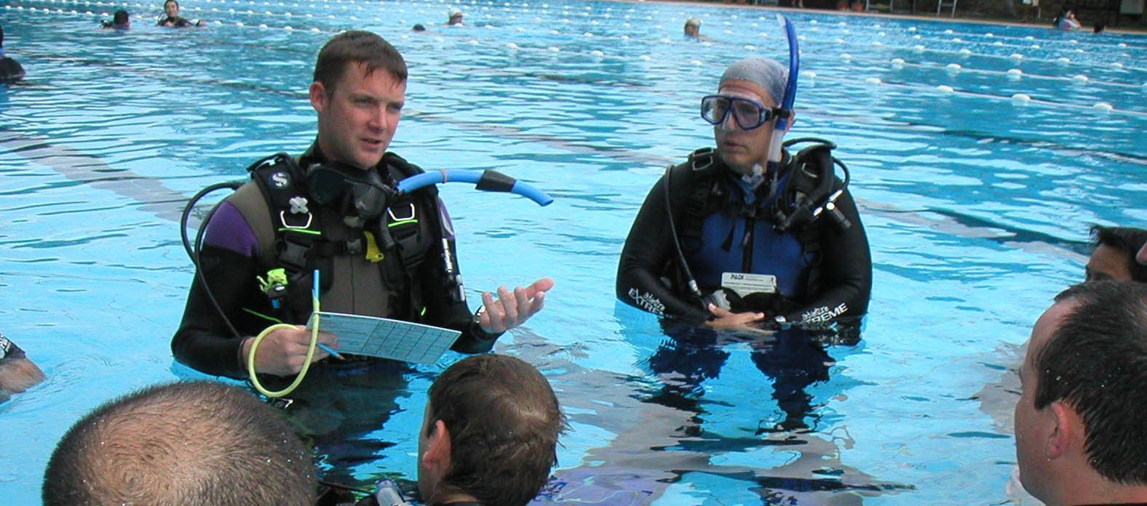
A PADI Course Director is an Instructor trainer. The Course Director rating denotes the highest Instructor achievement in the PADI system. Course Directors are among the dive industry’s most influential opinion makers and play a critical role in shaping the attitude and abilities of PADI Instructors. They serve as role models for other PADI Members in regards to PADI instruction, diver training and professionalism.

Scubadive West www.scubadivewest.com is located in an idyllic situation on the sheltered shores of Killary Fjord with a lovely beach in front and high mountains at the rear. Diving occurs year round in any and all weathers. Being on the most westerly coast in Europe, washed by the Gulf Stream, provides wonderful diving in clear Atlantic waters with an abundance of colourful marine life.
Its private sheltered cove is ideal for training, refresher and night dives. There is a lot to see in the cove with no currents on a sandy bottom that slopes gently down to 15 metres interspersed with small reefs.
Local sites offer wreck and scenic dives with dramatic seascapes, drop-offs, canyons, walls and caves with seals and dolphins - all common features of west coast diving. Hand feeding the Killary congers is popular feature dive!

